Test Case: tc002_SPX_Dev5_Crear_Requisicion_Spot_Con_FAD_Tipo_Cobro_CC
Step 1 - Enter username and password and click to button Enter : Credentials Entered
Image file-name: QC_Testing-tc002_SPX_Dev5_Crear_Requisicion_Spot_Con_FAD_Tipo_Cobro_CC-1790175403664

Step 2 - Select to UEN and Access to Spot Buy Requisitions : UEN Correctly selected and Correct access
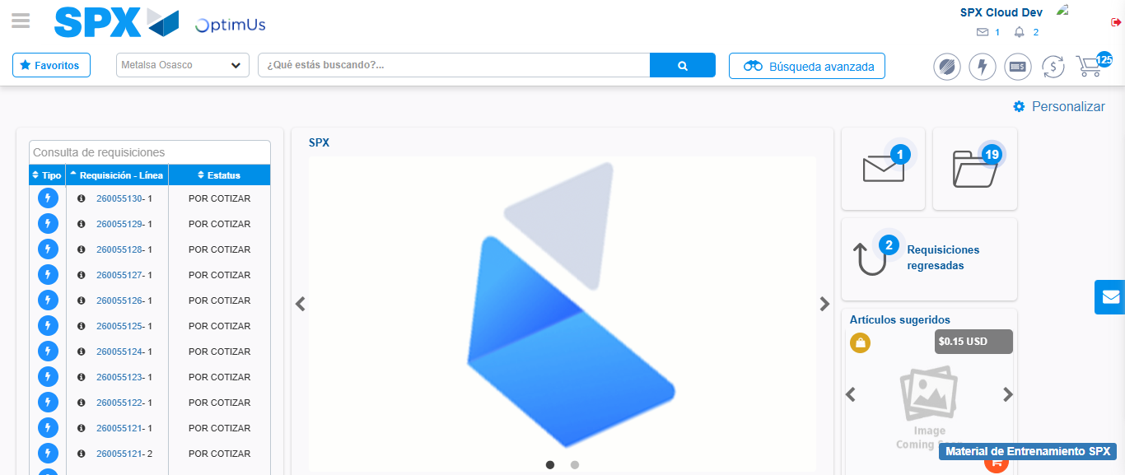Image file-name: QC_Testing-tc002_SPX_Dev5_Crear_Requisicion_Spot_Con_FAD_Tipo_Cobro_CC-1790175427229

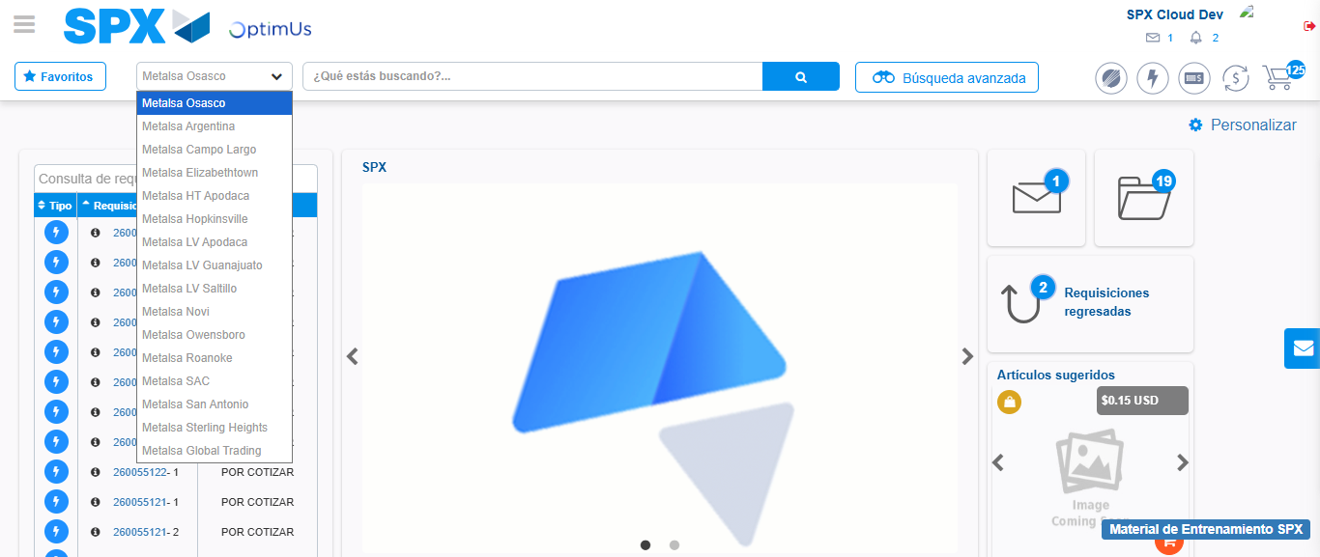Image file-name: QC_Testing-tc002_SPX_Dev5_Crear_Requisicion_Spot_Con_FAD_Tipo_Cobro_CC-1790175427983

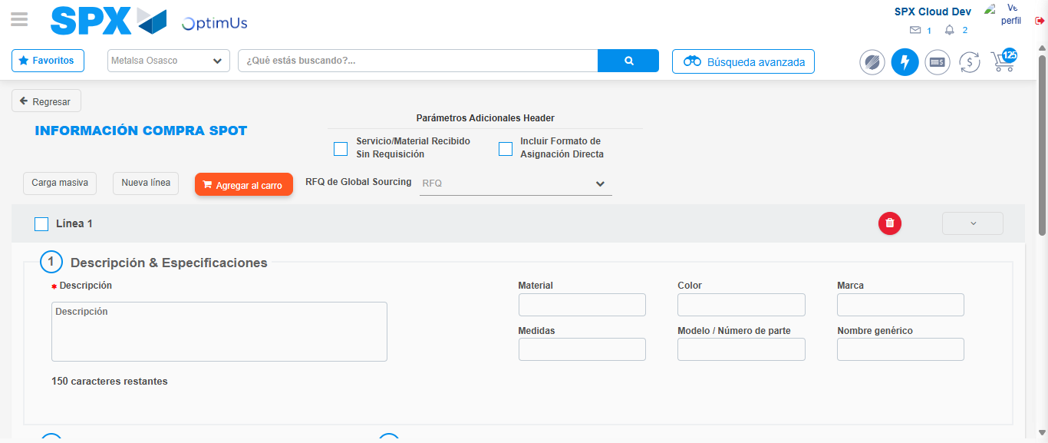Image file-name: QC_Testing-tc002_SPX_Dev5_Crear_Requisicion_Spot_Con_FAD_Tipo_Cobro_CC-1790175432858

Step 3 - Add FAD to Requisition: FAD Successfully Added
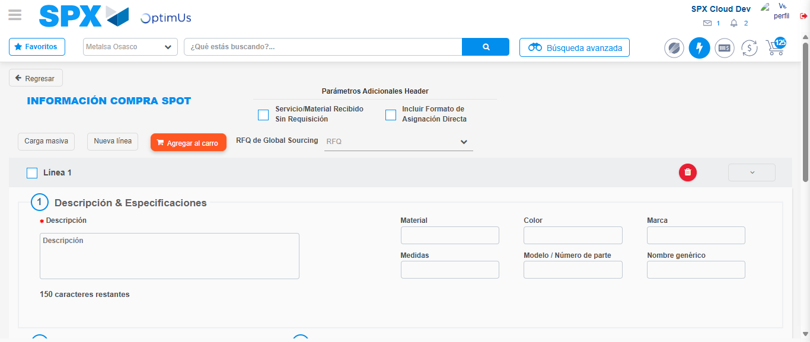Image file-name: QC_Testing-tc002_SPX_Dev5_Crear_Requisicion_Spot_Con_FAD_Tipo_Cobro_CC-1790175433153

Image file-name: QC_Testing-tc002_SPX_Dev5_Crear_Requisicion_Spot_Con_FAD_Tipo_Cobro_CC-1790175433380

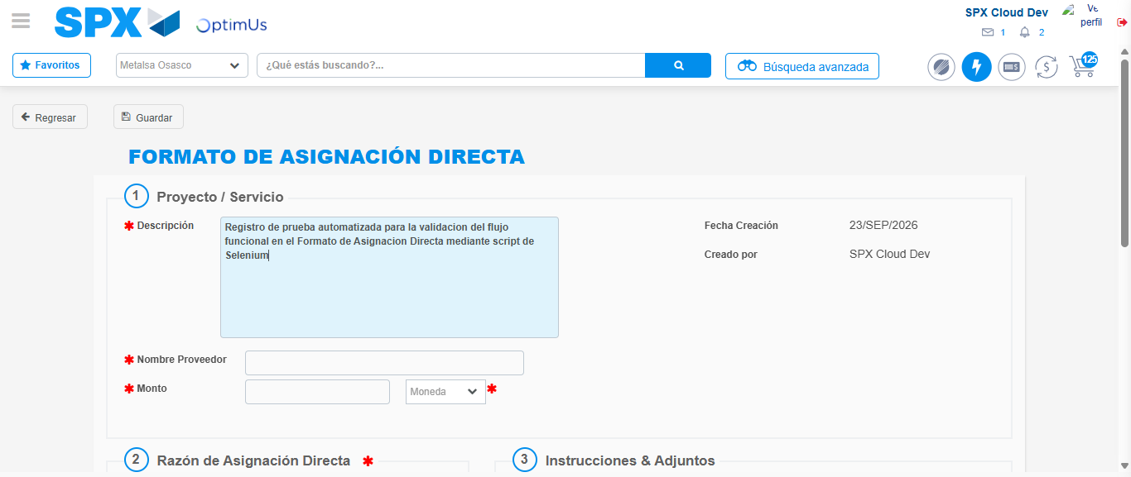Image file-name: QC_Testing-tc002_SPX_Dev5_Crear_Requisicion_Spot_Con_FAD_Tipo_Cobro_CC-1790175436383

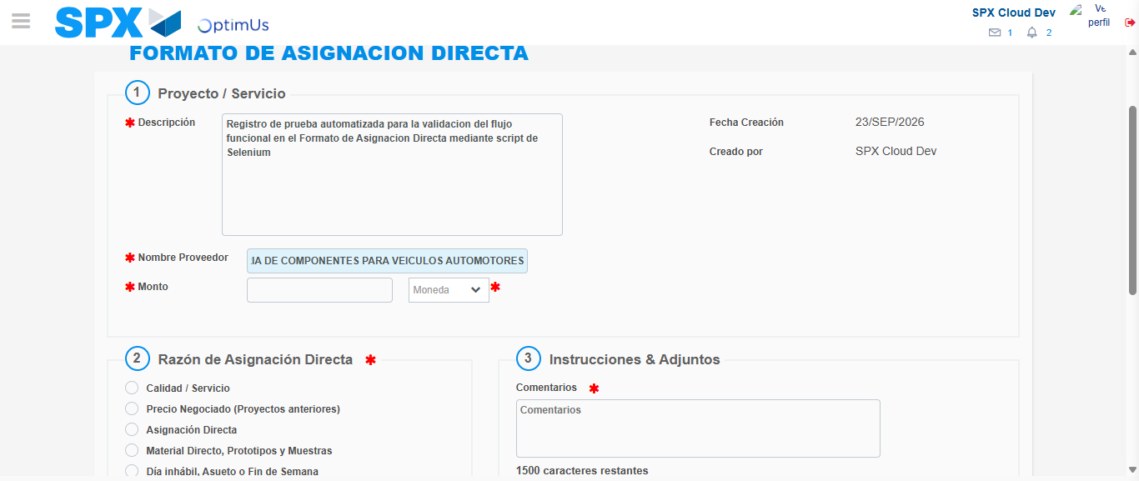Image file-name: QC_Testing-tc002_SPX_Dev5_Crear_Requisicion_Spot_Con_FAD_Tipo_Cobro_CC-1790175446298

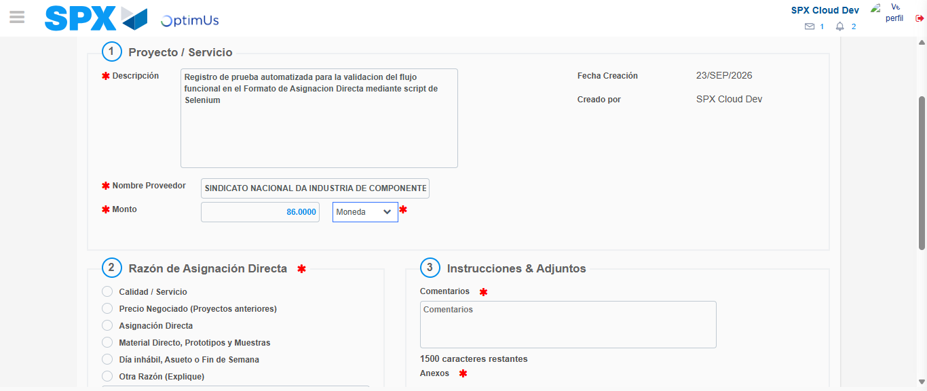Image file-name: QC_Testing-tc002_SPX_Dev5_Crear_Requisicion_Spot_Con_FAD_Tipo_Cobro_CC-1790175446944

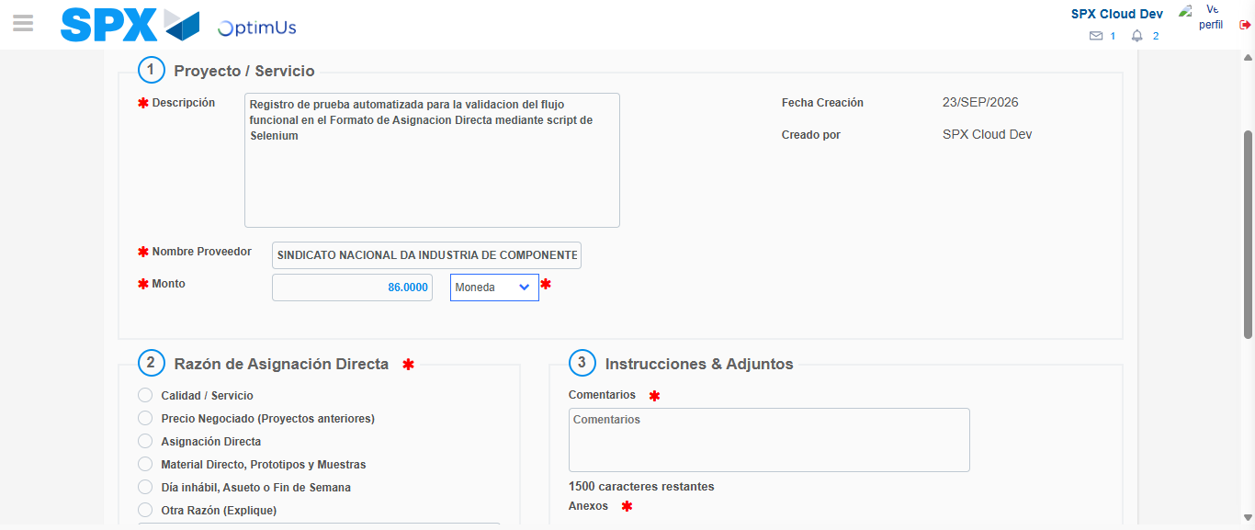Image file-name: QC_Testing-tc002_SPX_Dev5_Crear_Requisicion_Spot_Con_FAD_Tipo_Cobro_CC-1790175447238

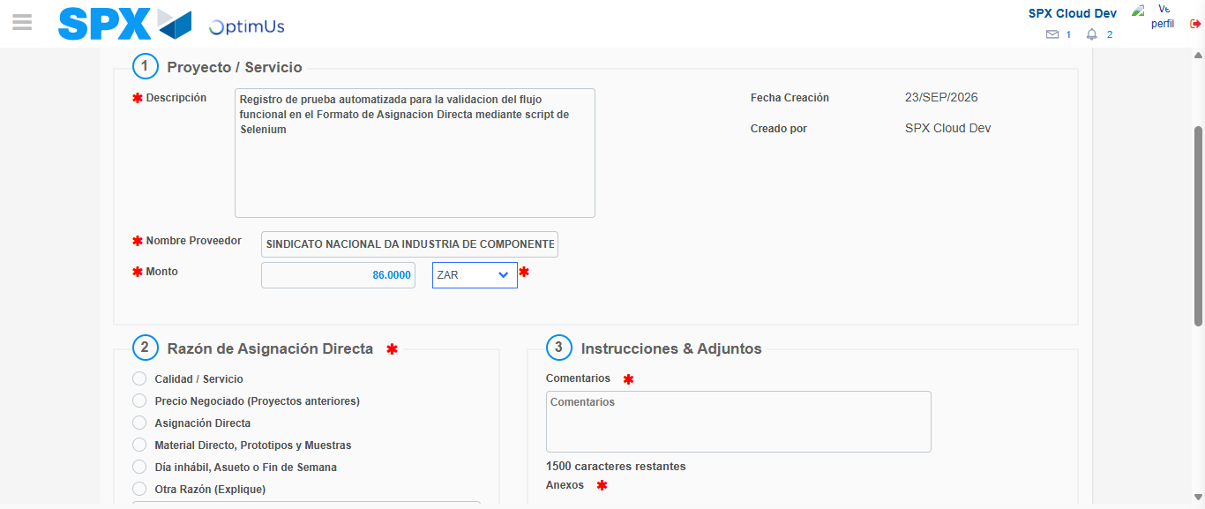Image file-name: QC_Testing-tc002_SPX_Dev5_Crear_Requisicion_Spot_Con_FAD_Tipo_Cobro_CC-1790175447796

Image file-name: QC_Testing-tc002_SPX_Dev5_Crear_Requisicion_Spot_Con_FAD_Tipo_Cobro_CC-1790175448101

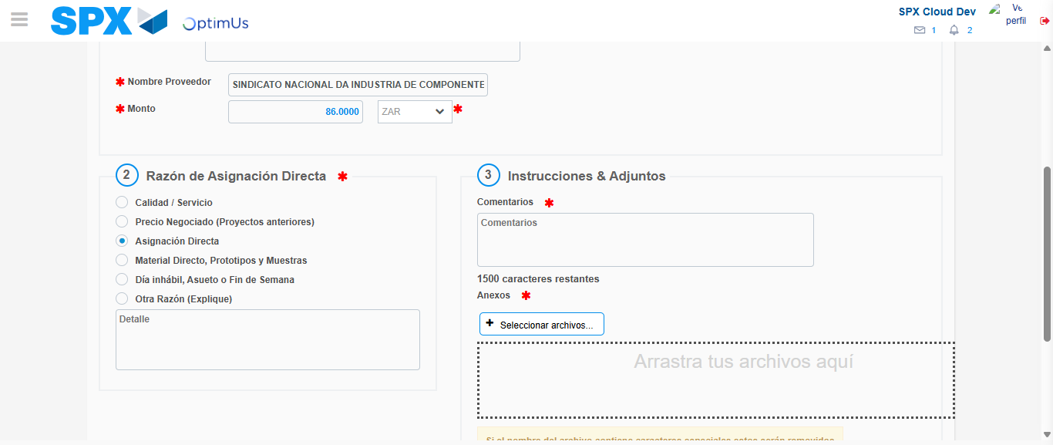Image file-name: QC_Testing-tc002_SPX_Dev5_Crear_Requisicion_Spot_Con_FAD_Tipo_Cobro_CC-1790175449084

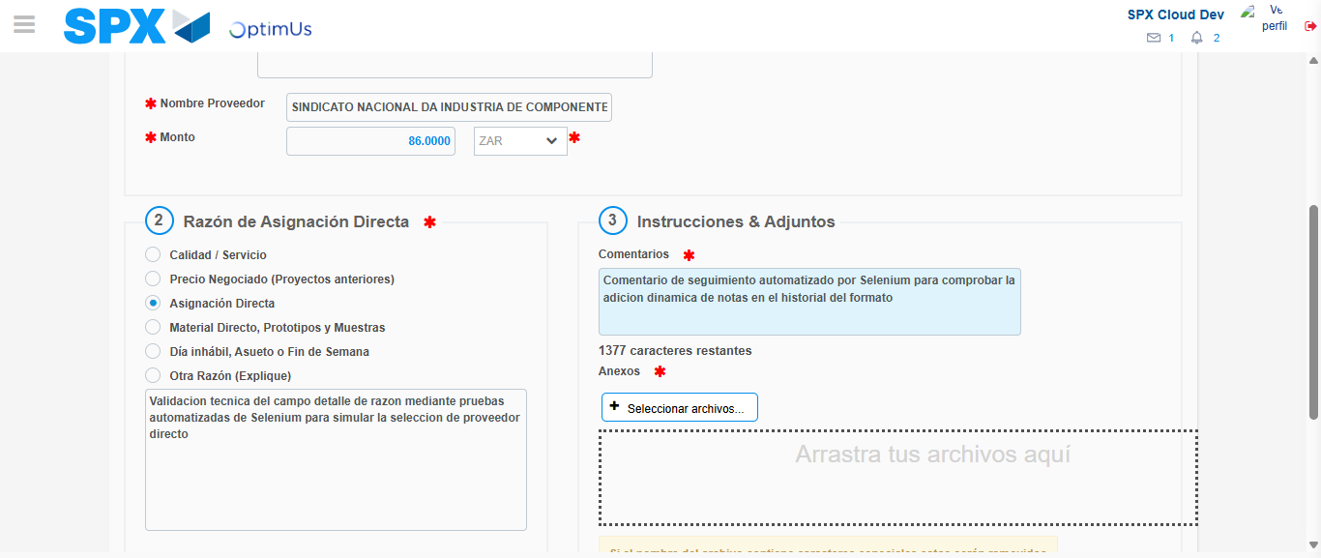Image file-name: QC_Testing-tc002_SPX_Dev5_Crear_Requisicion_Spot_Con_FAD_Tipo_Cobro_CC-1790175460754

Image file-name: QC_Testing-tc002_SPX_Dev5_Crear_Requisicion_Spot_Con_FAD_Tipo_Cobro_CC-1790175461857

Step 4 - Data Capture Spot Buy Requisition: Data captured correctly
Image file-name: QC_Testing-tc002_SPX_Dev5_Crear_Requisicion_Spot_Con_FAD_Tipo_Cobro_CC-1790175433153

Image file-name: QC_Testing-tc002_SPX_Dev5_Crear_Requisicion_Spot_Con_FAD_Tipo_Cobro_CC-1790175433380

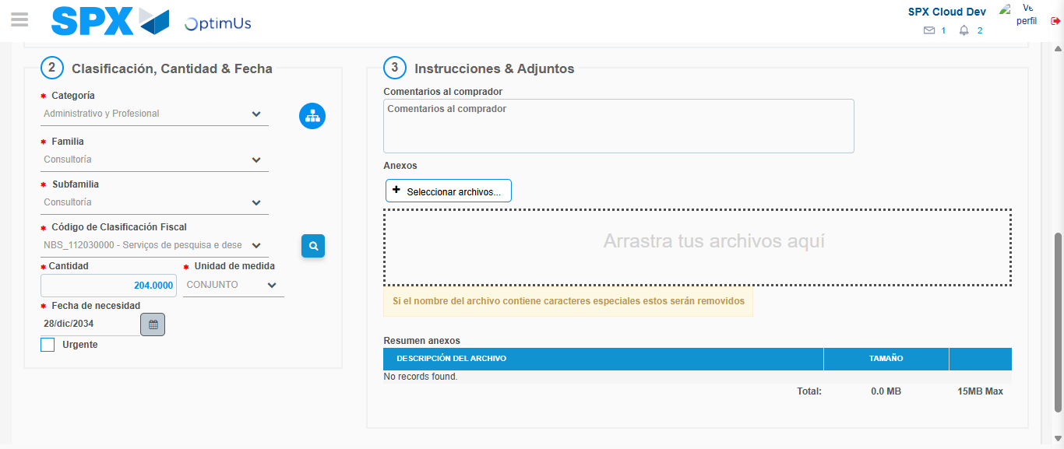Image file-name: QC_Testing-tc002_SPX_Dev5_Crear_Requisicion_Spot_Con_FAD_Tipo_Cobro_CC-1790175508075

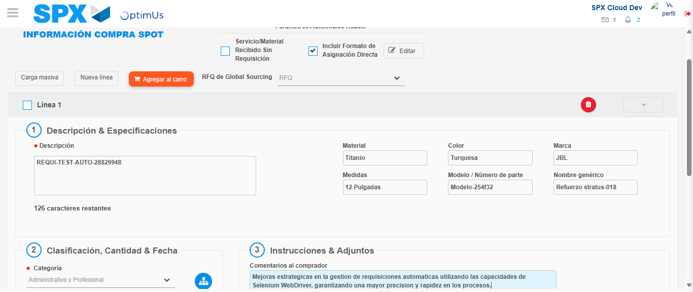Image file-name: QC_Testing-tc002_SPX_Dev5_Crear_Requisicion_Spot_Con_FAD_Tipo_Cobro_CC-1790175508877

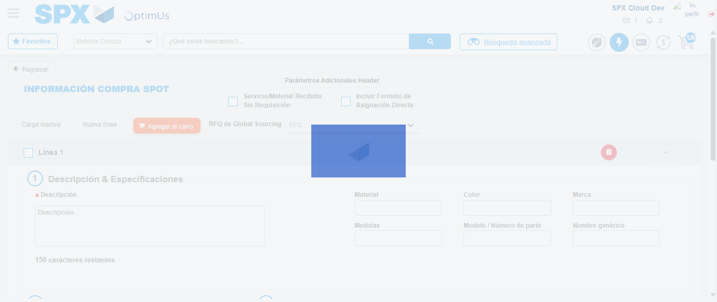Image file-name: QC_Testing-tc002_SPX_Dev5_Crear_Requisicion_Spot_Con_FAD_Tipo_Cobro_CC-1790175523058

Step 8 - Return to Main Page SPX : Return to Main Page SPX
Image file-name: QC_Testing-tc002_SPX_Dev5_Crear_Requisicion_Spot_Con_FAD_Tipo_Cobro_CC-1790175427229

Image file-name: QC_Testing-tc002_SPX_Dev5_Crear_Requisicion_Spot_Con_FAD_Tipo_Cobro_CC-1790175427983

Image file-name: QC_Testing-tc002_SPX_Dev5_Crear_Requisicion_Spot_Con_FAD_Tipo_Cobro_CC-1790175432858

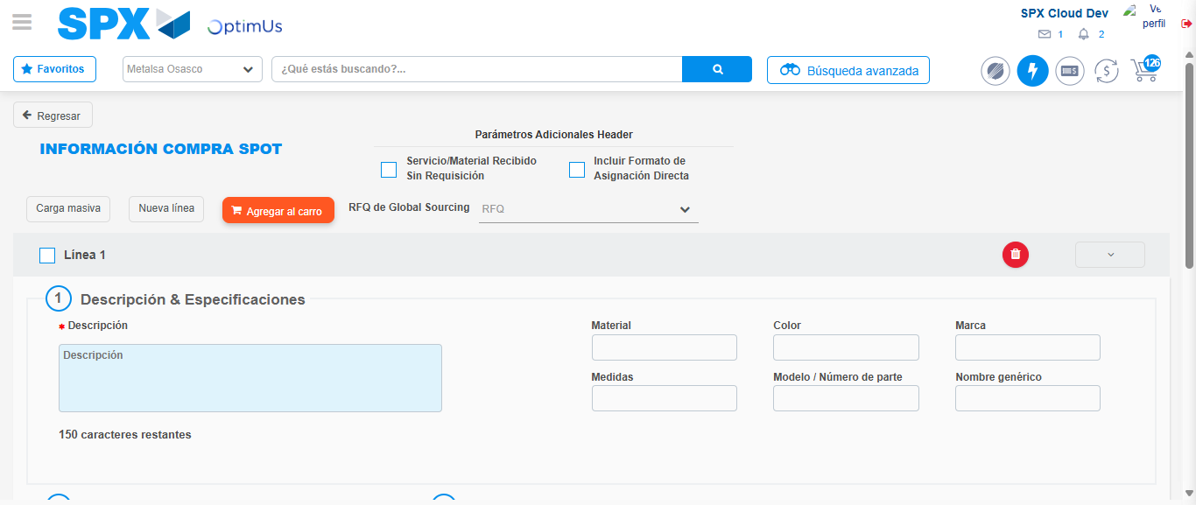Image file-name: QC_Testing-tc002_SPX_Dev5_Crear_Requisicion_Spot_Con_FAD_Tipo_Cobro_CC-1790175525270

Image file-name: QC_Testing-tc002_SPX_Dev5_Crear_Requisicion_Spot_Con_FAD_Tipo_Cobro_CC-1790175525441

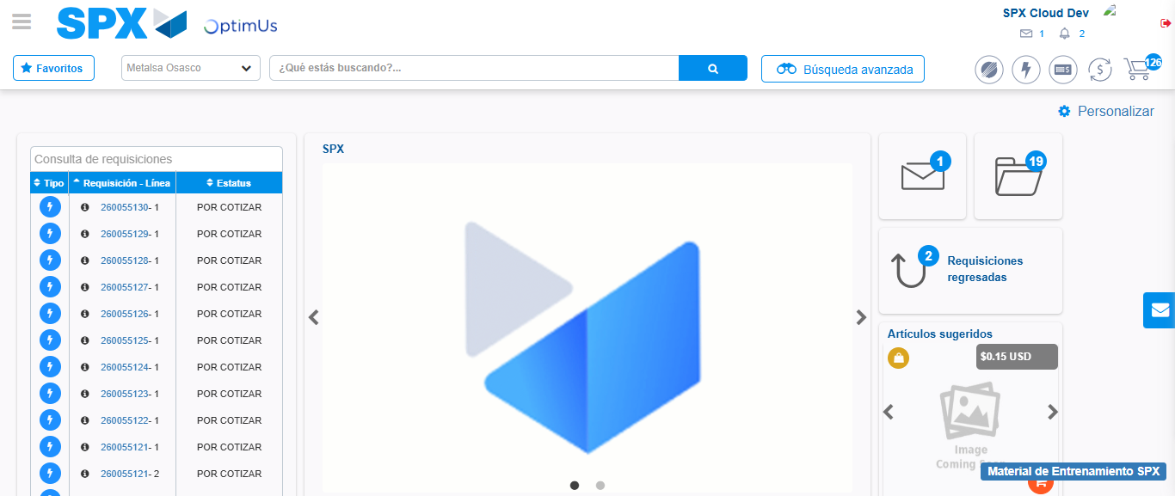Image file-name: QC_Testing-tc002_SPX_Dev5_Crear_Requisicion_Spot_Con_FAD_Tipo_Cobro_CC-1790175546142

Step 9 - Log Out : Log Out SPX
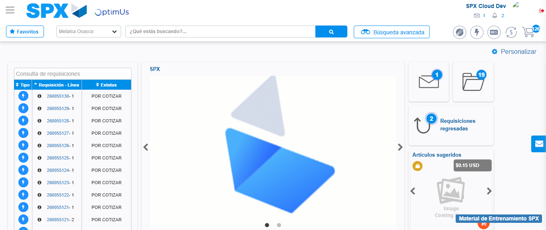Image file-name: QC_Testing-tc002_SPX_Dev5_Crear_Requisicion_Spot_Con_FAD_Tipo_Cobro_CC-1790175546530

